Prometheus installation in aws Ubuntu

Download souce file from net by using curl or wget command

$curl -LO https://github.com/prometheus/prometheus/releases/download/v2.9.2/prometheus-2.9.2.linux-amd64.tar.gz

$sha256sum prometheus-2.9.2.linux-amd64.tar.gz

$ tar –xvf Prometheus-2.9.2.linux-amd64.tar.gz

$ ls -ltr

$cd prometheus-2.9.2.linux-amd64

$ls -ltr

$ sudo cp prometheus-2.9.2.linux-amd64/prometheus /usr/local/bin

$ sudo cp prometheus-2.9.2.linux-amd64/promtool /usr/local/bin/

$

$ ./prometheus --config.file=prometheus.yml &

command used to run in the backgroung &

$ you want to add any target servers we can add in prometheus.yml file 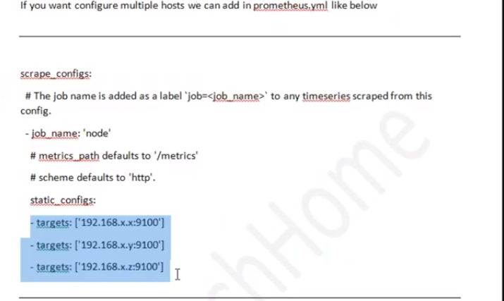

$ ./prometheus --config.file=prometheus.yml & --command use to run prometheus in background

--> serverdnsname:9090 -- we can get prometheus dashbaord

--> serverdnsname:9090/graphs --we can server graph logs

--> serverdnsname:9090/metrics --we can get metrics logs ---it is go languagae which undersand by metrics

ex: to monitor

promhttp_metric_handler_requests_total

